Evaluation of Model Predictions
To evaluate the model’s predictions against observed depth occupancy, we summarized depth occupancy at various time scales and corresponding predictions across each of the selected features. For seasonal effects, we compared the monthly proportion of fish in each depth bin in the validation set to the monthly mean probability of fish in each depth bin as predicted by the model. To evaluate diurnal variation, we converted our sin_sun and cos_sun features back into radians, binned that feature, and then computed the actual proportions of the fish at depths lower than 25 m across month and day for both the training and validation sets. This was then compared to the monthly mean probability of depth occupancy below 25 m across the day as predicted by the model over the validation set. Finally, for each of our selected environmental features (mixed layer thickness, salinity, and nitrate), we binned our environmental feature and then, per month, compared observed proportion of fish below 25 m over the validation and training sets to the corresponding predicted proportions over the validation set.
Informing Risk Mitigation
To illustrate how the model predictions can guide mitigation of incidental capture of Chinook salmon near the seafloor we performed an inference over the Gulf of Alaska in the year of 2022 and then used the predictions to explore how our features drive risk.
First, in the same manner as described for model training, we built a dataset of model features that included each depth bin, over every single H3 resolution 4 cell, in each hour, over the full year of 2022 in the Gulf of Alaska and Eastern Bering Sea. This resulted in over 96 million entries. Using AWS Batch, we then ran model inference over these points to determine the likelihood associated with each of the entries. We then subset this data to just the GOA east of ---145° longitude and removed entries where the average depth was >600 m as Chinook salmon were not seen deeper that this in our dataset.
Using this dataset we then explored the effect each of our features had on depth occupancy in the lowest depth bin available to each H3 cell. First, to look at seasonality, we computed the 5th percentile risk in the lowest depth bin per H3 cell across the months of February and August (winter and summer respectively). Then to better understand seasonal and diurnal variation we plotted the risk per depth bin across the entire year for one H3 cell (index=840ccebffffffff, lat=55.9N, lon=-158.2E) near Chignik, AK where a number of the fish in this study were tagged and released. To further understand variation in depth occupancy as a function of time of day, we computed, per H3 cell on August 15 and February 15, the average of our sin_sun feature with depth occupancy was below its 5th percentile for that day and H3 cell. Positive values of this aggregate indicate that occupancy is minimized during the day, negative values indicate a minimization at night. Finally, to explore the effects of our environmental features on near sea floor depth occupancy, for each H3 cell on August 15 and February 15 we computed the mean salinity, mixed layer thickness, and nitrate concentration in the lowest depth bin available to the H3 cell as well as the minimum likelihood of occupancy in that lowest depth bin across the day. Minimum likelihood vs environmental features were then plotted for depth bins 50 m – 150 m.

Results
Model Evaluation
The selected model (model D in table 1) used, as features, depth_bin, season, our diel feature, and the environmental covariates nitrate, salinity, and mixed layer thickness. As a baseline, the null model (equal likelihood given to each depth bin) had a loss over the validation decisions of 1.740. Addition of the depth bin brought this down to 1.457. The next most important feature, season, brought the loss down to 1.368 and then diel and the environmental features lowered this further to 1.352 and 1.339 respectively. We found that additional features did not further improve the model over the validation set.
The importance of depth bin as a feature was expected due to the strong skew toward shallower depths in the raw data (table 2). Over 46% of the samples were in the shallowest depth bin (0-25 m) and over 85% of the samples were in the first 100 m of water. Therefore, providing the model with information to separate depth bins generated a significant drop in loss.
Season followed depth in importance due to meaningful shifts in depth occupancy over each month (figure 1). Starting in October we see a drop in the occupancy in the 0-25m bin and higher occupancy in the deeper bins. Then around April this begins to shift and by May we see the highest occupancy of the 0-25m bin. Over the rest of the spring/summer occupancy in this shallowest bin then drops off to repeat the cycle in October. Our model followed this overall pattern amongst seasons with a slight shift in the peak occupancy of the 0-25m bin.
The smaller drop in loss upon addition of the diel features is due to a combination of uneven diel patterning across both the year and across fish (figure 2), however our model was able to capture these patterns with reasonable accuracy. August through October sees the most marked diel pattern with fish occupying lower depths during the day and shifting toward the 0-25 m bin at night. However, the specific proportions are relatively unclear as there was meaningful separation between those proportions in the training and validation sets. From November through February, we see much reduced variation over the course of the day and then in March through May the pattern reverses with fish rising slightly in the day and dropping at night. In all months the model followed these patterns.
Finally, the addition of environmental features follows that of the diel features in its high variability across seasons and data sets (figures 3-5). While mixed layer thickness, nitrate, and salinity were selected because they were the only features that individually showed any improvement, their overall effect on the loss is quite weak. Higher nitrate concentrations show a tendency to vary positively with occupation in depth bins lower than 25m however there is considerable variance between the training and validation sets. Furthermore, during the spring and summer months this pattern seems to largely vanish. The same pattern is seen with salinity with a possible negative relationship in August and September. Finally mixed layer thickness has a very spurious relationship over the year with some months exhibiting what appears to be a negative relationship with occupancy below 25 m and others a positive relationship. Beyond this, in the summer there is very little variability in mixed layer thickness and once again there is considerable variation between training and validation data sets. Overall though, the model follows these patterns, spurious as they are, with reasonable accuracy.

Assessing Likelihood of Occupancy Near the Seafloor
Starting at a high level we see considerable variability in the minimum likelihood of occupancy in the lowest depth bin per H3 cell both across seasons and across space (figure 6). In February there is an overall pattern of minimum likelihood that increases as you move away from the coast along the shelf and then a precipitous drop as you reach the edge of the shelf. Within this, however, are a series of hotspots where minimum likelihood is considerable higher than in neighboring cells. In August minimum likelihood drops meaningfully as compared to February, but we see that the location of hotspots is largely maintained.
Near Chignik (figure 7) overall depth occupancy and diel variation changes over the course of the year. The winter months see the lowest overall depth occupancy but over the course of winter diel variability decreases to its minimum in February and March. After this occupancy starts to shift toward the 0-25m bin and then stabilizes in May without much change in diel variation. Then beginning in August the diel variation rises rapidly, maintains itself until October and then begins to taper off again. In sum this means that while average predicted occupancy is shallowest in the spring/early summer it is from August to October that the shallowest instantaneous occupancy is predicted in this particular H3 cell.
Not only does the variability across the day change but the cycle flips in some places as well. In August we see that minimum likelihood of occupancy in the lowest depth bin per H3 cell occurs at night (figure 8). However, during February the time of day that minimizes that same likelihood is quite varied. In general, we see very few cells where nighttime minimizes those likelihoods and instead see a tendency toward minimization during the day or at dawn or dusk.
Variability in minimum likelihood is induced by our environmental features as well. By splitting our H3 cells by their overall depth, clear gradients in minimal likelihood arise in February for our environmental features (figure 9). As either salinity, nitrate, or mixed layer thickness increase there is a tendency for occupancy in the lowest depth bin to increase. However, during August these gradients all but disappear in part because the minimum likelihood of being at depth drops precipitously during this month.

Model | Features | LC Train | LC Val | LD Train | LD Val
Null |  |  |  | 1.835 | 1.740
A | depth_bin | 0.470 | 0.526 | 1.412 | 1.457
B | A + season | 0.438 | 0.487 | 1.330 | 1.368
C | B + diel | 0.429 | 0.480 | 1.313 | 1.352
D | C + nitrate, salinity, mlt | 0.426 | 0.474 | 1.308 | 1.339
Table 1: Performance with Each Additional Feature. LC and LD indicate loss (categorical cross entropy) over the contrasts and decisions respectively. From top to bottom each model incorporates a new set of features until we arrive at the selected model D. The Null model assumes each depth bin is as likely as all the others.

Depth Bin | Proportion of Samples
[0, 25] | 46.4%
(25, 50] | 16.6%
(50, 75] | 13.0%
(75, 100] | 9.6%
(100, 150] | 10.1%
(150, 200] | 3.1%
(200, 250] | 0.6%
(250, 300] | 0.3%
(300, 400] | 0.1%
(400, 500] | <0.1%
Table 2: Depth Skew. Observed proportion of samples per depth bin.
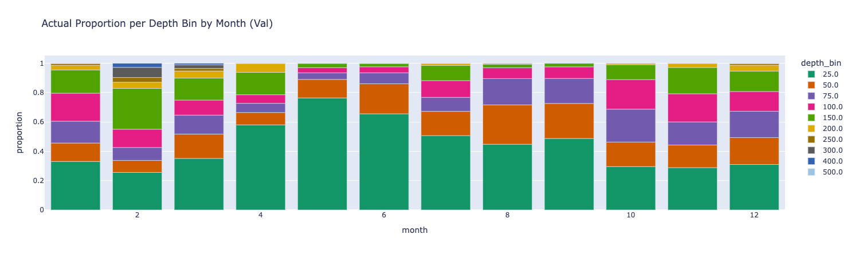
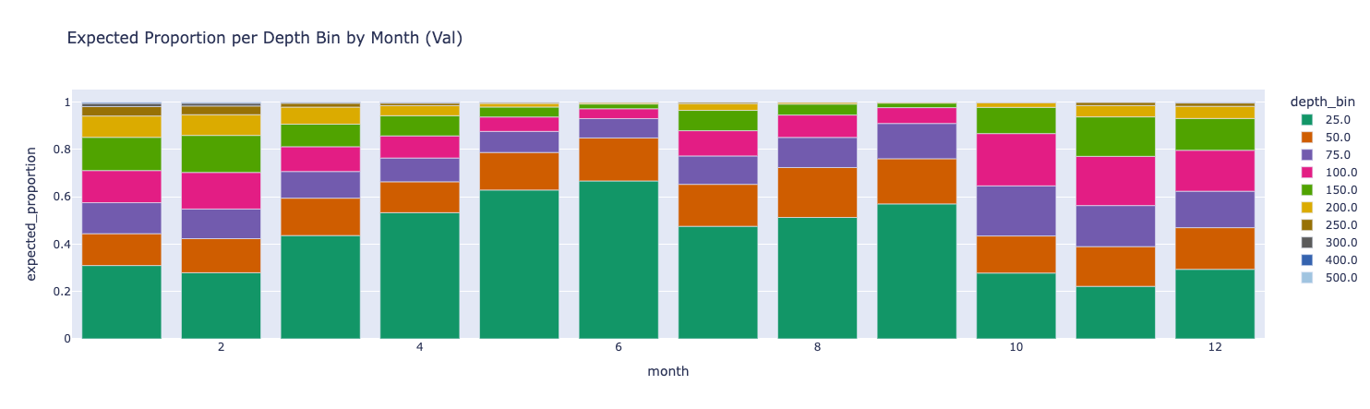
Figure 1: Actual and predicted proportion of fish in each depth bin by month over the validation dataset using our selected model.
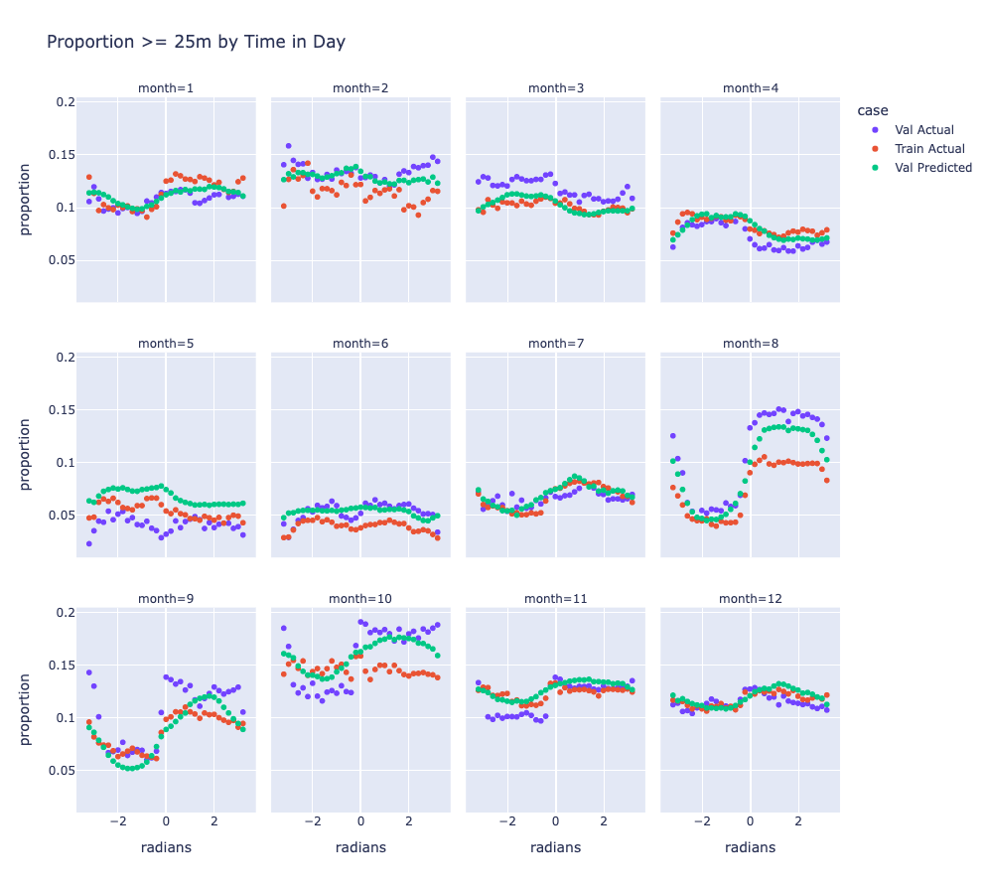
Figure 2: Diel Variation x-axis is the passage of the day in radians (starting at night (negative radians), sunrise at 0 radians, and then moving through the day (positive radians). y-axis is the actual and then expected probability of occupancy in the depth bins >=25 m. Note the variation between the training set and the validation set in the actual proportions.
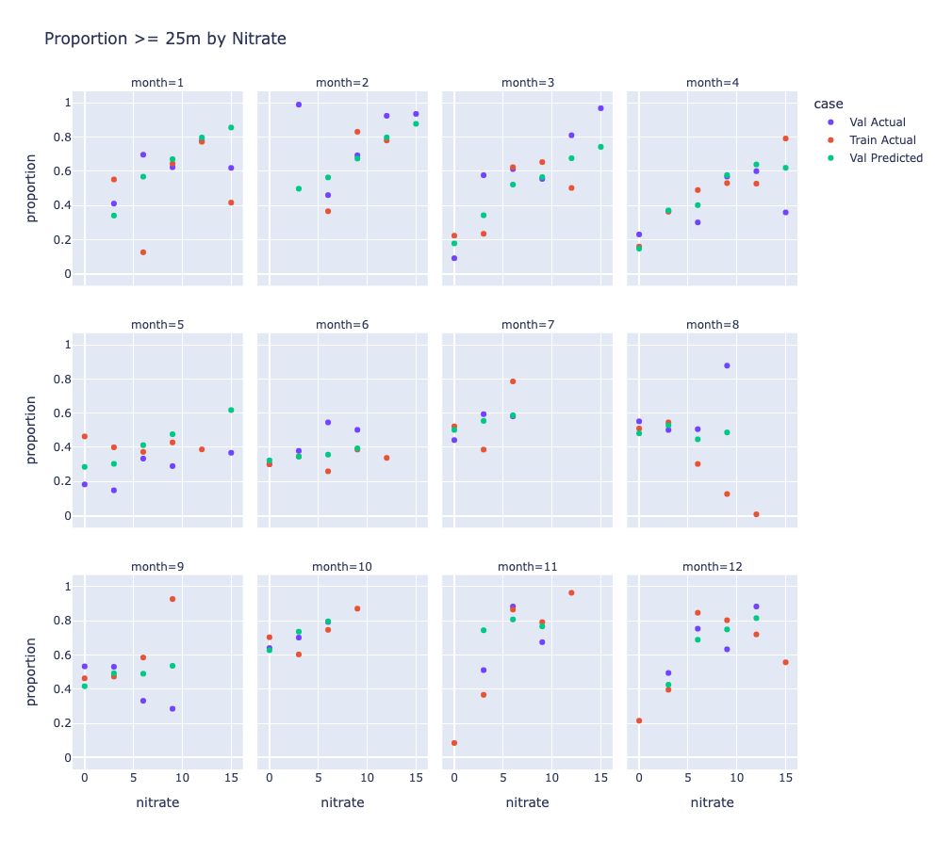
Figure 3: Proportions by Nitrate Bin Observed vs predicted proportions of fish below 25m as a function of nitrate concentrations.
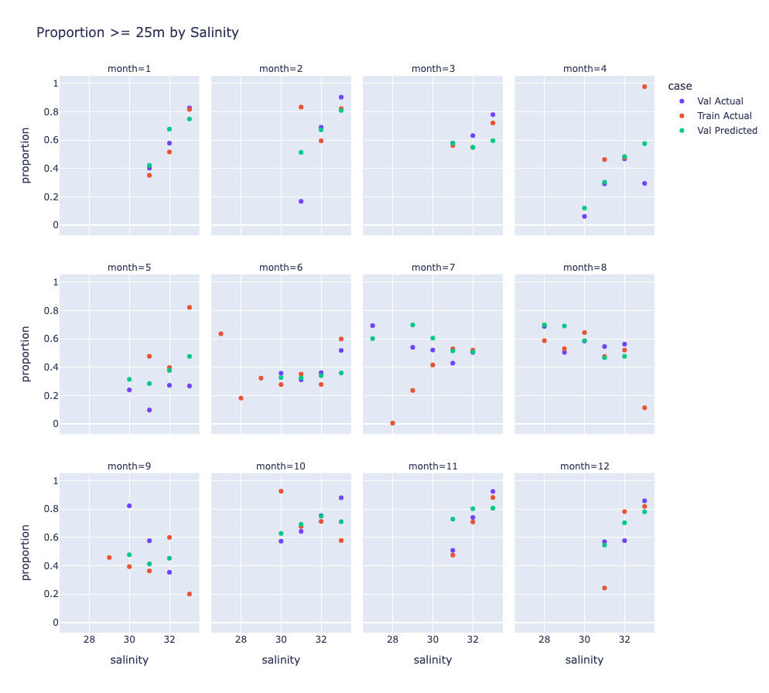
Figure 4: Proportions by Salinity Bin Observed vs predicted proportions of fish below 25m as a function of salinity.
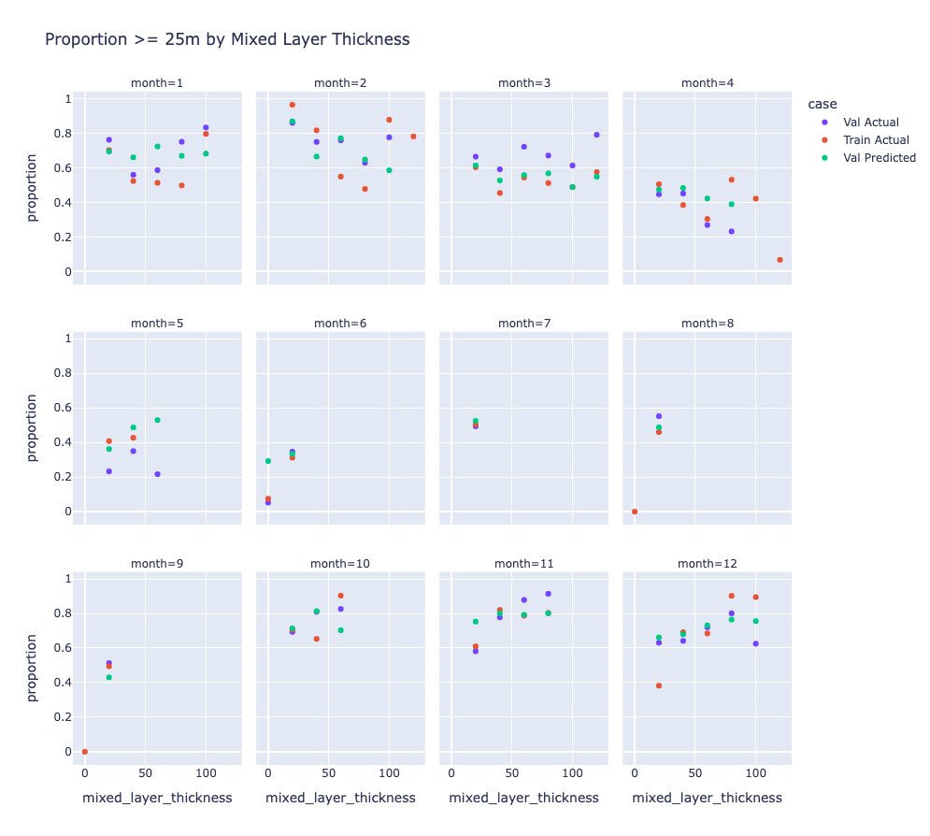
Figure 5: Proportions by Mixed Layer Thickness Bin Observed vs predicted proportions of fish below 25m as a function of mixed layer thickness.
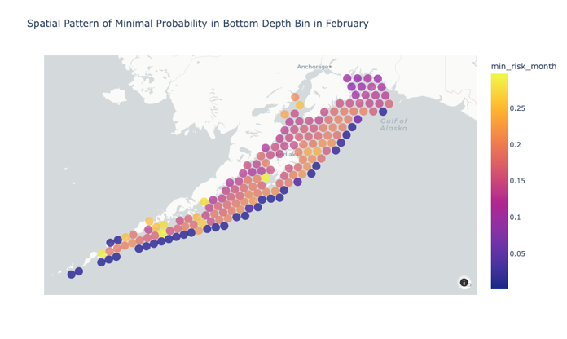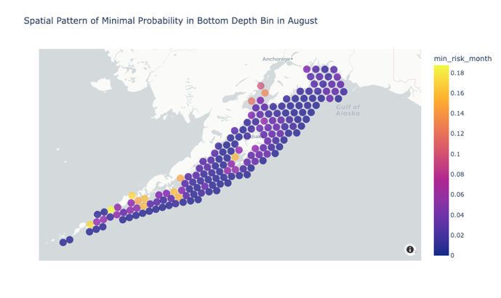
Figure 6: Spatial Distribution of Minimum Risk Minimum predicted likelihood in the lowest depth bin available to each H3 cell in February and August.
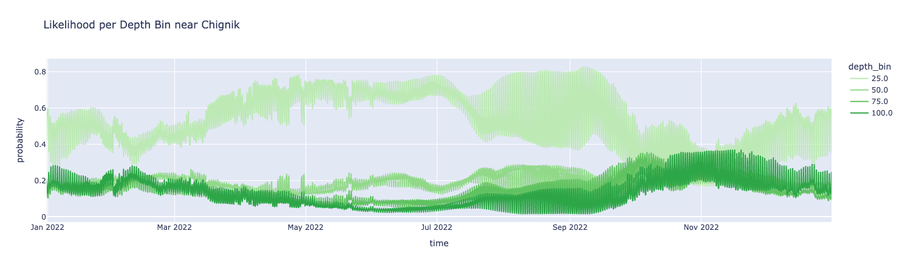
Figure 7: Full Year of Likelihoods Predicted likelihood per depth bin across all hours in 2022 for an H3 cell near Chignik.
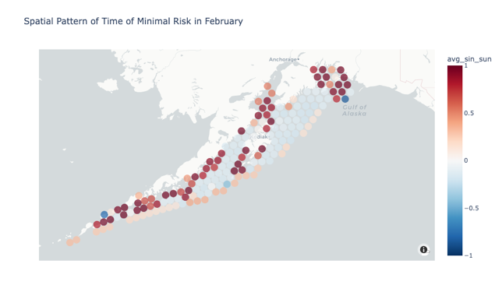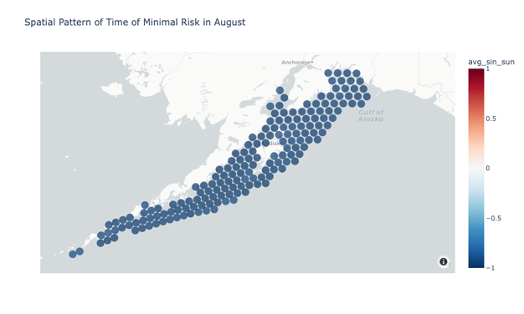
Figure 8: Time of Day Minimization plotted is the portion of the day where risk is minimized for February 15 and August 15. Negative values (blue) indicate nighttime whereas positive values (red) indicate day.
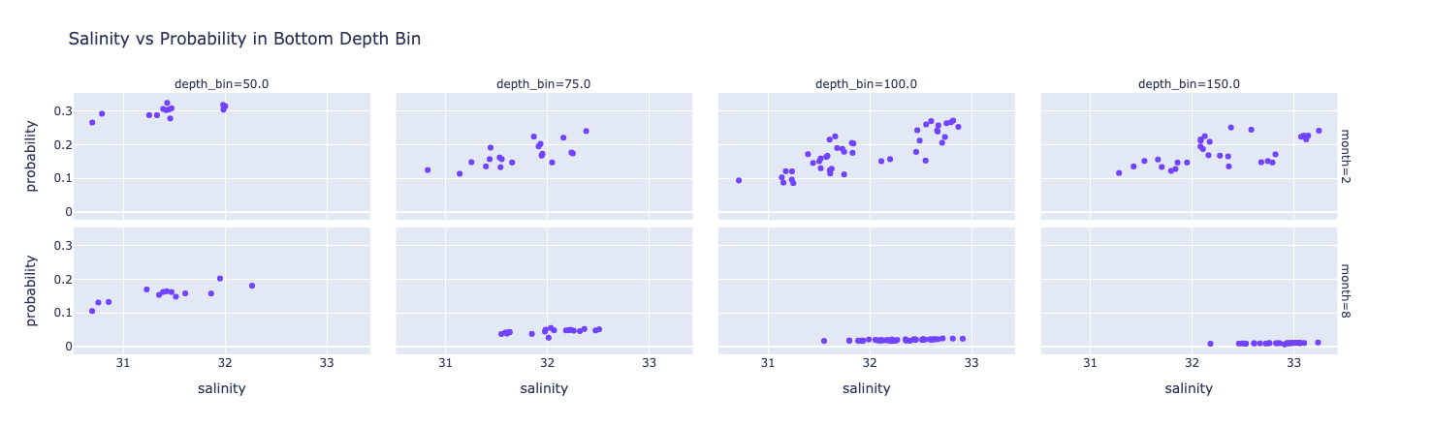
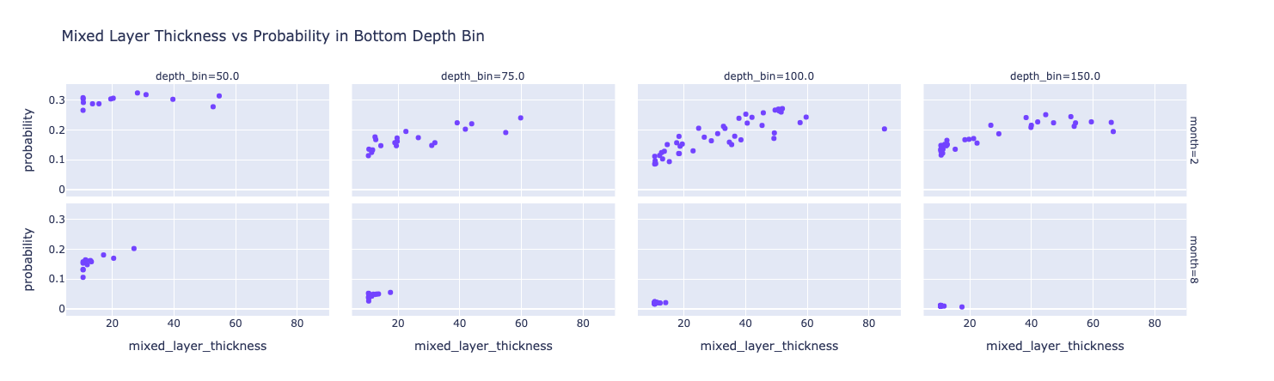
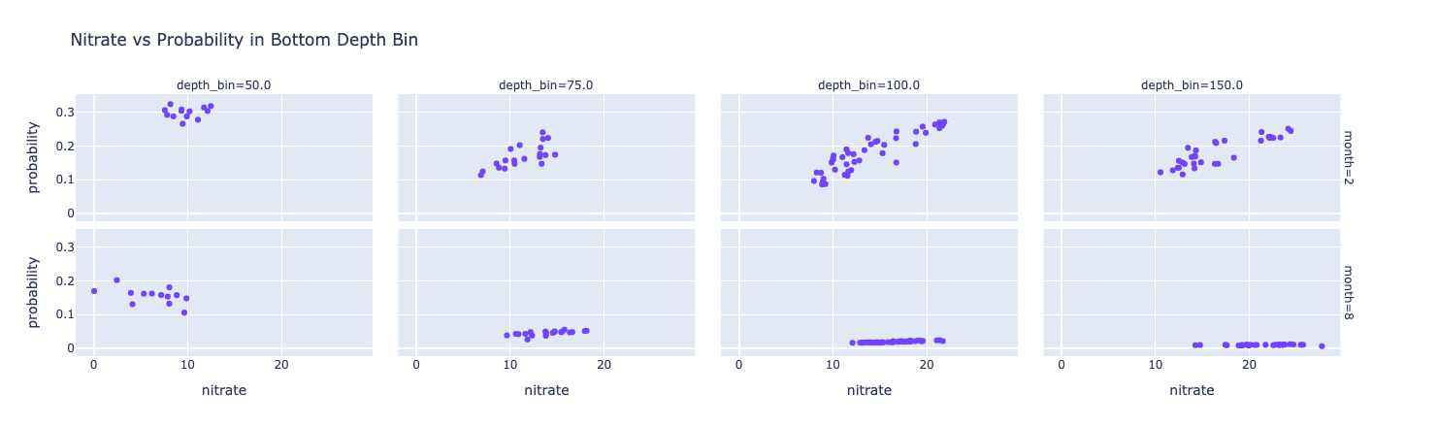
Figure 9: Likelihood of Bottom Occupancy vs Environmental Features Per H3 cell the minimum likelihood of occupancy in the lowest depth bin vs mean environmental features in that cell-bin combination. This was taken over February and August 15.

